# Visualisation using Bar plot

import matplotlib.pyplot as plt

import pandas as pandas

Students_Performance_data = pandas.read_csv("StudentsPerformance.csv")

gender_frequency = Students_Performance_data['gender'].value_counts()

plt.title("Gender Separation")

plt.xlabel("Gender")

plt.ylabel("count")

plt.bar(gender_counts.index,gender_frequency.values,color="yellow")

The below bar chart best describes the male and female gender discrimination and displays the count of male and females.

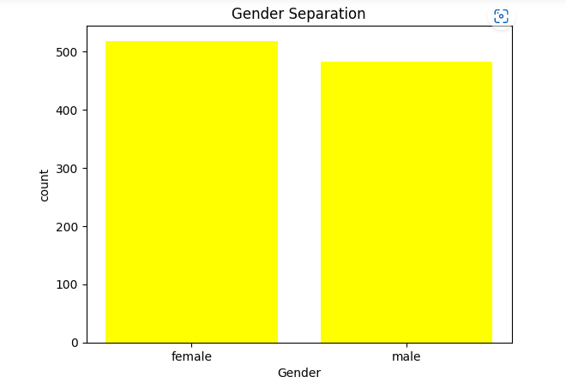

1. **Visualisation Using HeatMap**

import matplotlib.pyplot as plt

import pandas as pandas

import seaborn as seaborn

Students_Performance_data = pandas.read_csv("StudentsPerformance.csv")

corr=Students_Performance_data.corr(numeric_only=True)

colormap = seaborn.color_palette("Greens")

seaborn.heatmap(corr,cmap=colormap,annot=True)

plt.title("Correlation Matrix")

plt.show()

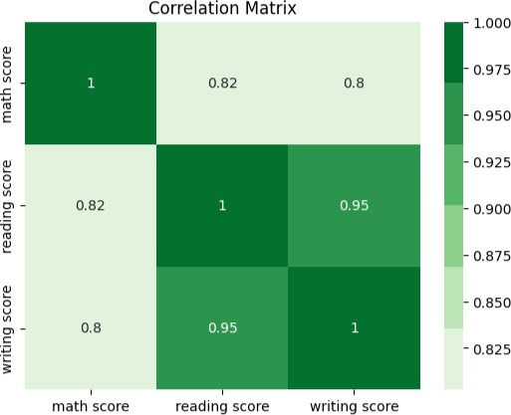

The Above Visualisation depics the relation between Maths score ,Reading Score and Writing Score.

# Visualisation using KDEPlot

# import matplotlib.pyplot as plt

# import pandas as pandas

# import seaborn as seaborn

# Students_Performance_data = pandas.read_csv("StudentsPerformance.csv")

# seaborn.kdeplot(x='writing score',data=Students_Performance_data,hue='lunch',fill=True,alpha=.3)

# plt.title('Writing Scores by Lunch Type')

# plt.xlabel('Writing Score')

# plt.show()

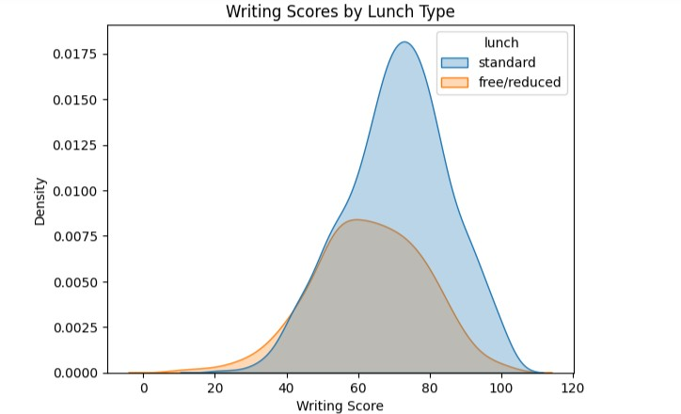

The Above graph best describes the density and writing scores and also depicts whether lunch is standard or free/reduced. This graph best describes the above fields.

# Visualisation Using Scatter Plot

import matplotlib.pyplot as plt

import pandas as pandas

import seaborn as seaborn

Students_Performance_data = pandas.read_csv("StudentsPerformance.csv")

plt.scatter(Students_Performance_data['math score'],Students_Performance_data['reading score'],color='red')

plt.title("Mathematics scores vs Reading scores")

plt.xlabel("Math Score from dataset")

plt.ylabel("reading score from dataset")

plt.show()

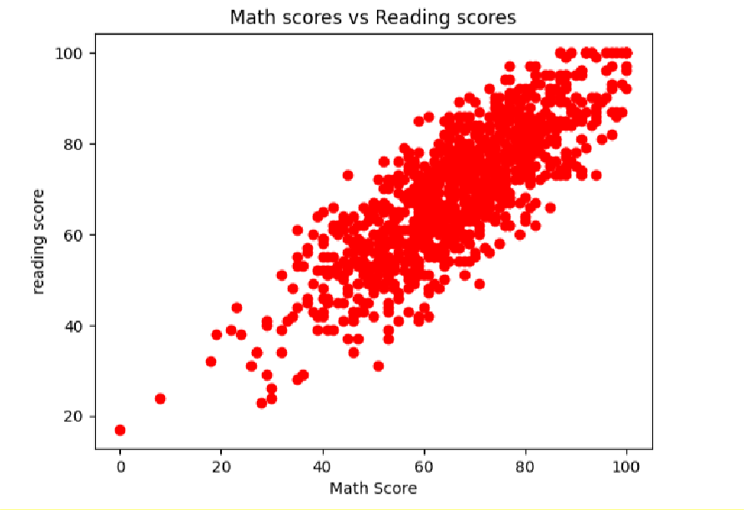

The above scatter plot best describes the Maths scores versus the Reading Scores and the plot best depics the comparion between them.

# Visualisation Using Box Plot

import matplotlib.pyplot as plt

import pandas as pandas

import seaborn as seaborn

Students_Performance_data = pandas.read_csv("StudentsPerformance.csv")

seaborn.boxplot(x="gender",y="math score",data=Students_Performance_data)

plt.title("Gender based math scores")

plt.show()

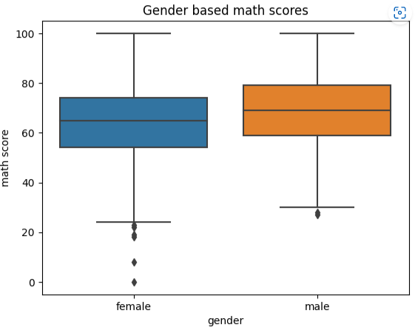

The above graph best describes the gender based math scores for both male and female. It best describes through plots on which has best math score based on gender.